**Chatbot For HealthCare**

**Software Requirement Specifications(SRS)**

**<Version 2.0>**

Project Work Phase-1 (ECS-799)

Degree

**BACHELOR OF TECHNOLOGY (CSE)**

|  |  |
| --- | --- |
| PROJECT GUIDE: | SUBMITTED BY: |
| **Mr. Aadiya Jain**  **Assistant Professor**  **CCSIT, TMU** | **Arjun Sharma TCA 1809067**  **Raushan Raj TCA 1809060**  **Nameera Miraj TCA 1911003** |

December, 2021



**FACULTY OF ENGINEERING & COMPUTING SCIENCES**

**TEERTHANKER MAHAVEER UNIVERSITY, MORADABAD**

**DECLARATION**

We hereby declare that this Project Report titled __ Artificial Chatbot for Health Care __ submitted by us and approved by our project guide, Faculty of Engineering & Computing Sciences. Teerthanker Mahaveer University, Moradabad, is a bonafide work undertaken by us and it is not submitted to any other University or Institution for the award of any degree diploma / certificate or published any time before.

|  |  |  |
| --- | --- | --- |
|  |  |  |
| **Project ID :** | Project Id |  |
| **Student Name:** | **Raushan Raj** | Signature |
| **Student Name:** | **Nameera Miraj** | Signature |
| **Student Name:** | **Arjun Sharma** | Signature |
|  |  |  |
| **Project Guide :** | **Mr. Aaditya Jain** | Signature |
|  |  |  |

Table of Contents

1. **PROJECT TITLE ....................................................................................................... 4**
2. **PROBLEM STATEMENT .......................................................................................... 4**
3. **PROJECT DESCRIPTION .......................................................................................... 4**

### SCOPE OF THE WORK.... ........................................................................................................................ 4

### PROJECT MODULES ............................................................................................................................... 5

* 1. CONTEXT DIAGRAM (HIGH LEVEL) ................................................................ **ERROR!BOOKMARK NOT DEFINED.**

1. **IMPLEMENTATION METHODOLOGY ...................................................................... 6**
2. **TECHNOLOGIES TO BE USED .................................................................................. 7**

### SOFTWARE PLATFORM .......................................................................................................................... 7

### HARDWARE PLATFORM.......................................................................................................................... 7

* 1. TOOLS, IF ANY .......................................................................................... **ERROR!BOOKMARK NOT DEFINED.**

1. **ADVANTAGES OF THIS PROJECT ............................................................................ 7**
2. **ASSUMPTIONS, IF ANY .......................................................................................... 8**
3. **FUTURE SCOPE AND FURTHER ENHANCEMENT OF THE PROJECT ........................... 8**
4. **PROJECT REPOSITORY LOCATION ........................................................................... 8**
5. **DEFINITIONS, ACRONYMS, AND ABBREVIATIONS ................................................... 9**
6. **CONCLUSION .......................................................................................................... 9**
7. **REFERENCES ...........................................................................................................11**

**Appendix**

**AppendixA: Data Flow Diagram (DFD)**

**AppendixB: Entity Relationship Diagram (ERD)**

**AppendixC: Data Dictionary (DD)**

**AppendixD: Screen Shots**

# Project Title

Explore how health care organizations can scale up their CX journey with Conversational AI. Categorize calls based on customer requirements with Conversational AI. Predictive Analytics.

Fast Implementation.

**Artificial Intelligence chatbot for health care**

# Problem Statement

In Today’s World Scenarios traditional method to getting appointment for doctor, standing in long queues for number of hours also doctors didn’t talk as if patient want more consult regarding their health. Also, Patient health record history, their previous prescribed medicine and what’s their suitable medicine all need an IT solution in terms of Artificial Intelligence. Artificial intelligence chatbot is a technology that makes interactions between man and machines using natural language possible

# Project Description

The purpose of this project is to provide the admin has to collect the patient’s medical history of records and filter it appropriately by applying data pre-processing techniques. Admin’s functionalities are to collecting the appropriate medical records of the patients, handle missing values, handling categorical values, creating sparse matrix representation, feeding data to the autonomous pipeline for predictions, selecting and training an appropriate machine learning algorithm.

The visitor can perform the basic task of the visitor is to access the Chatbot from the front end and reply to its queries with a binary response (Yes/No). The visitor will be shown a confidence interval related to a certain prognosis which needs to further investigated and experimented with for better results. The first step is to start their procedure, then one by one all the symptoms come in client’s screens. They will have to reply with yes or no answer.

Once a problem is found then they will have to click yes, then the patient can see their problem on screen. The best part is that it will provide the doctor’s information like the Doctor’s name and his/her website link. So thar can easily find their doctor with don’t face with any type of problem, and start their treatment. This will prepare with the help of Chatbot so that one can even check their problem at any time. You have to just reply with the clicking of button Yes or No.

## Scope of the Work

1. This project consists number of patients history, their health records and previous prescriptions.
2. This work help visitor to get health related advice and suggests experts of their fields.
3. Provide maximum accuracy in result of health issues based on Symptom’s Based Query.
4. Chatbots have an ability to engage customers. They can also foster a relationship between customer and brands, and deliver a more personalized experience. Bots impart information about new product launches and timely updates to the customers.

## Project Modules

1. **Problem Recognition**: The Problem Recognition Module is responsible for understanding the visitor’s problem through basic Yes/No queries.
2. **Evaluation and synthesis**: This module evaluate the problem into different segments and synthesis the collect data and feed into the module.
3. **Modelling**: This module is responsible for processing evaluated data and determine the issue occur in the data entry.
4. **Result:** After the model process the problem, this led to the result of the problem recognized by the HealthCare Chatbot.
5. **Category:** Machine Learning, AI
6. **Programming Language:** Python
7. **IDE:** Jupyter notebook
8. **Front End:**Tkinter
9. **Back End:** Python: NumPy, Pandas, MessaseBox, WebBrowser
10. **Prerequisities:**Python,Machine Learning
11. **Intended Audience:** Education, Developers, Data Scientists, AI professionals

# Implementation Methodology

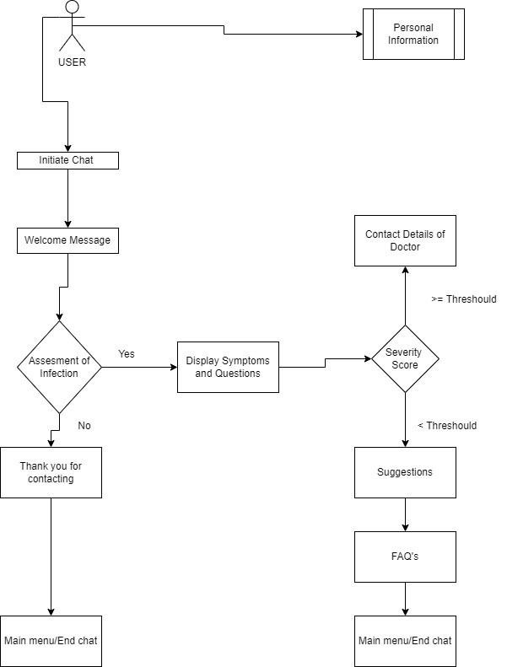

# Technologies to be used

## Software Platform

**a)Front-end**

1. **Tkinter:-**Tkinteris the standard GUI library for Python. Python when combined with Tkinter provides a fast and easy way to create GUI applications. Tkinter provides a powerful object-oriented interface to the Tk GUI toolkit. Creating a GUI application using Tkinter is an easy task. All you need to do is perform the following steps − (a) Import the Tkinter module. (b)Create the GUI application main window. (c) Add one or more of the above-mentioned widgets to the GUI application.
2. **Jupyter Notebook: -** As a data scientist still learning in an educational setting, you might use one main tool, while you may focus on *another, different one* as a professional data scientist. Of course, using multiple tools or platforms is beneficial, but there is a time and place for specific ones. Two beneficial and important tools that many data scientists use areJupyter Notebook and PyCharm
3. **Python: -** Python is a very **productive language**. Python is an interpreted language which means that Python directly **executes the code** line by line. Python doesn’t know the type of variable until we run the code. It automatically assigns the data type during **execution** Python comes under the **OSI approved** open-source license. This makes it **free** to **use** and **distribute**

**b)Back-end**

mysql, database

## Hardware Platform

4 GB RAM, 20 GB Hard Disk, OS windows 7 +.

# Advantages of this Project

1. **24/7 Availability** – Customers needn’t wait for the next available operator when chatbots are part of the communication strategy on a round-the-clock basis.
2. **Instant Response** – Chatbots can handle the queries of thousands of customers instantly as well as simultaneously and improve the[average response time.](https://www.revechat.com/blog/response-time/)
3. **Consistency in Answers** – The use of chatbots can help businesses maintain a great level of consistency in answers and improve customer experience with the brand.
4. **Omni-channel** – AI-powered bots come with omni-channel messaging support features which help customers communicate with businesses through various channels such as websites, Facebook, etc.
5. **Personalization** – Bots can ensure a touch of personalization by engaging customers with one-on-one conversations, maintaining a natural-sounding tone, and by being good at interactive communication.
6. **A reduction-** in human error and more accurate diagnosis.
7. **Well-recorded** -and reliable monitoring of a patient's progress.
8. **Well-recorded** -and reliable monitoring of a patient's progress.

# Assumptions, if any

# Common mistakes of a chatbot project called assumption have a following type.

## Wrong objective:- The best chatbot experiences are a guided conversational experience not an open ended conversational experiences. The biggest mistake you can make is to buy the hype and try to implement a human-like chatbot that engages in conversation with customers almost at a human level. Many companies have tried this and failed. Trying to build a chatbot outside of the scope of things it does really well is always a problem.

## Bad design and development issues:- Chatbots need to be designed conservatively, the scope needs to be made very clear and the conversation needs to be escalated to a human too often rather than not often enough. It goes without saying the developers working on the bot need to be competent and familiar with best practice in this area. A poorly designed chatbot causes users to use it in a way that was not intended. This obviously causes frustration and has all sorts of negative repercussions.

## Wrong technological approach:- It is a mistake to choose a black box approach to conversations. Black box solutions are data driven solutions where the logic is essentially held in the AI algorithms. The problem with this is that no one knows for sure what the AI solution will do, it’s extremely difficult to debug, it cannot be comprehensively tested and new information may change its behaviour.

## Wrong platform:- Building these components from scratch is an extremely time consuming exercise. Of course, simple drag and drop frameworks have very generic and limited versions of this functionality and cannot be easily customized.

# Future Scope and further enhancement of the Project

A chatbot is a computer system, which can interact with users by using natural language. Normally, it is designed to serve in a certain domain such as online shopping, online frequently asked questions (FAQ) and also assistant system. Users can easily use it without background knowledge or experiences. Moreover, chatbot can serve many people at the same time with the same topic and without getting bored. Consequently, this may be the suitable capability to be adopted in public service such as the medical service. Hence, the objective of this work is to increase the service capability and decrease the operation cost of medical consultant service by using the chatbot.

# Project Repository Location

*<Guidelines: Mention the location of the latest Source Code and all related documents, like- Project Synopsis Report, Project Progress updates, Project Requirement Details, Project Report (Softcopy), Test Repository (all test scenarios, test cases etc.) used for Functional Testing of the project etc. The repository location must be somewhere in CCSIT-Lab>*

|  |  |  |  |  |
| --- | --- | --- | --- | --- |
| **S#** | **Project Artifacts (softcopy)** | **Location**  (Mention Lab-ID, Server ID, Folder Name etc.) | **Mr Aaditya Jain** | **Verified by Lab In-Charge** |
| 1. | Project Synopsis Report  (Final Version) |  | Name and  Signature | Name and  Signature |
| 2. | Project Progress updates |  | Name and  Signature | Name and  Signature |
| 3. | Project Requirement specifications |  | Name and  Signature | Name and  Signature |
| **S#** | **Project Artifacts (softcopy)** | **Location**  (Mention Lab-ID, Server ID, Folder Name etc.) | **Mr Aaditya Jain** | **Verified by Lab In-Charge** |
| 4. | Project Report (Final  Version) |  | Name and  Signature | Name and  Signature |
| 5. | Test Repository |  | Name and  Signature | Name and  Signature |
| 6. | Project Source Code (final version) with executable |  | Name and  Signature | Name and  Signature |
| 7. | Any other document |  | Name and  Signature | Name and  Signature |

# Definitions, Acronyms, and Abbreviations

*<Guidelines: Provide the definitions of all terms, acronyms, and abbreviations required to properly interpret the SRS. This information may be provided by reference to one or more appendices in the SRS or by reference to documents. This information may be provided by reference to an Annexure >*

|  |  |
| --- | --- |
| **Abbreviation** | **Description** |
|  |  |
|  |  |
|  |  |
|  |  |

# Conclusion

A chatbot is a computer system, which can interact with users by using natural language. Normally, it is designed to serve in a certain domain such as online shopping, online frequently asked questions (FAQ) and also assistant system. Users can easily use it without background knowledge or experiences. Moreover, chatbot can serve many people at the same time with the same topic and without getting bored. Consequently, this may be the suitable capability to be adopted in public service such as the medical service. Hence, the objective of this work is to increase the service capability and decrease the operation cost of medical consultant service by using the chatbot.

***Example:***

*Time and money are one of the most important factors to any organization. Implementing such software in the college stationery department can surely be a profitable deal as this application helps to carry out tasks with ease and thereby reduces time and money on manpower and materials. This is an open source application so that others can edit and transform this system application according to their needs.*

# References

## [www.w3schools.c](http://www.w3schools.co/)[om](http://www.w3schools.com/)[www.stackoverflow.c](http://www.stackoverflow.co/)[om](http://www.stackoverflow.com/)[www.](http://www.i/)[it-ebooks.com](http://www.it-ebooks.com/)

## <https://botpress.com/blog/successful-chatbot-projects-avoid-these-mistakes>

## https://www.happyfox.com/chatbot/?utm_campaign=hf-cb-20&utm_medium=ppc&utm_source=googleads&utm_content=chatbot-demo&utm_term=chatbot&gclid=Cj0KCQiAq7COBhC2ARIsANsPATHayY5J2LFB3kDdIiHArIqyceY_bsNOBOJYJrpgU56GMSZQVXJygC4aAhmYEALw_wcB

## https://medium.com/@botsideapp/3-major-problems-with-chatbots-and-chatbot-development-503d84e176aa

## https://www.investopedia.com/terms/c/chatbot.asp#:~:text=A%20chatbot%20is%20a%20computer,through%20any%20major%20messaging%20applications.

## <https://www.smatbot.com/?utm_source=Google%20ads&utm_medium=Search&utm_campaign=SmatbotINDIA&gclid=Cj0KCQiAq7COBhC2ARIsANsPATGyehz8DgFaJID9r7VG0z2iPgyUF3tRSg04Ai8wLkn2MVRcjj7zxTcaAgDPEALw_wcB>

## https://www.oracle.com/in/chatbots/what-is-a-chatbot/

Visual Stdio Code or google.colab [ [Website]](https://jupyter.org/)

Python Language [ [Website ]](https://julialang.org/)

|  |  |  |  |  |
| --- | --- | --- | --- | --- |
| **S#** | **Reference Details** | **Owner** | **Version** | **Date** |
| 1. | Project Synopsis | <Project Group ID> | 2.0 | 03-12-21 |
| 2. | Project Requirements | <Project Group ID> | 2.0 | 03-12-21 |
| 3. |  |  |  |  |

**Annexure A Data Flow Diagram (DFD)**

**(Mandatory)**

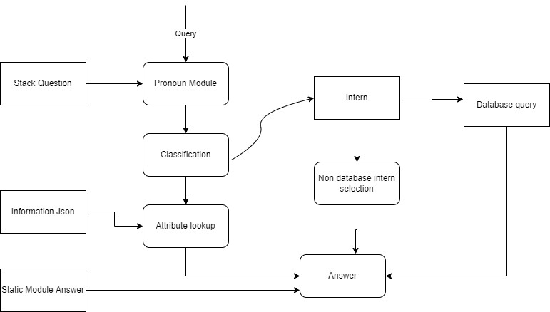

**Annexure B Entity-Relationship Diagram (ERD)**

**(Mandatory)**

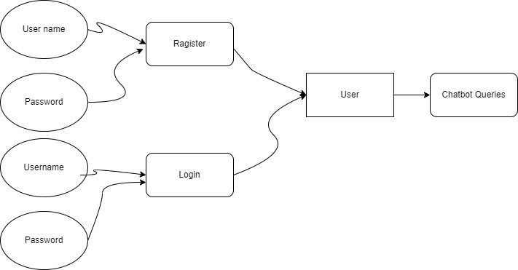

**Annexure C Data Dictionary (DD)**

**(Mandatory)**

**Example:**

**User Table (USR)**

|  |  |  |
| --- | --- | --- |
| **Fields** | **Data type** | **Description** |
| USR-Name | Text | Admin name |
| USR-Password | Text | Admin password |
| USR-Contact-No | Number | Admin Contact |
| USR-Address | Text | City |

**Supplier Table (SUPP)**

|  |  |  |
| --- | --- | --- |
| **Fields** | **Data type** | **Description** |
| SUPP-ID | Number | Supplier ID |
| SUPP-Name | Text | Supplier Name |
| SUPP-Address | Text | Supplier Address |
| SUPP-Contact | Number | Supplier Contact |
| SUPP-Credit-Limit | Number | Credit Limit |

**Annexure D Screen Shots-01**

*<Guidelines: Show all Pages>*

**Home Page:**

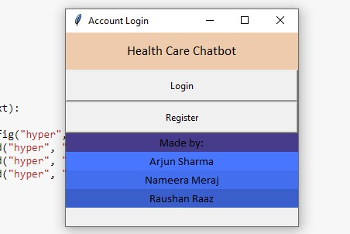

**-02**

**Login Page:** 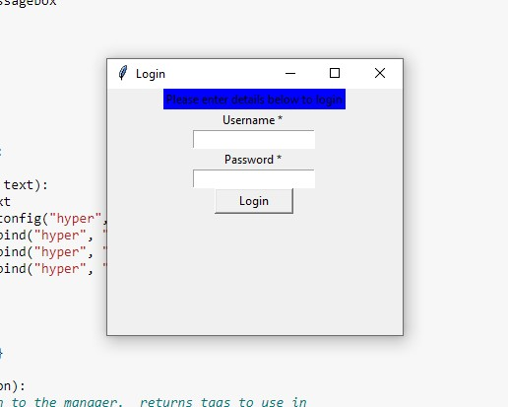

**-03**

**Register Page:** 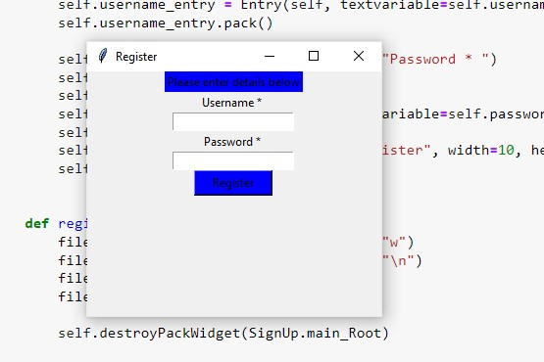

**-04**

**Process Page:** 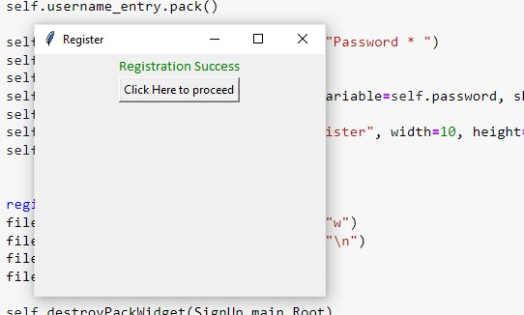

**-05**

**User Page:**

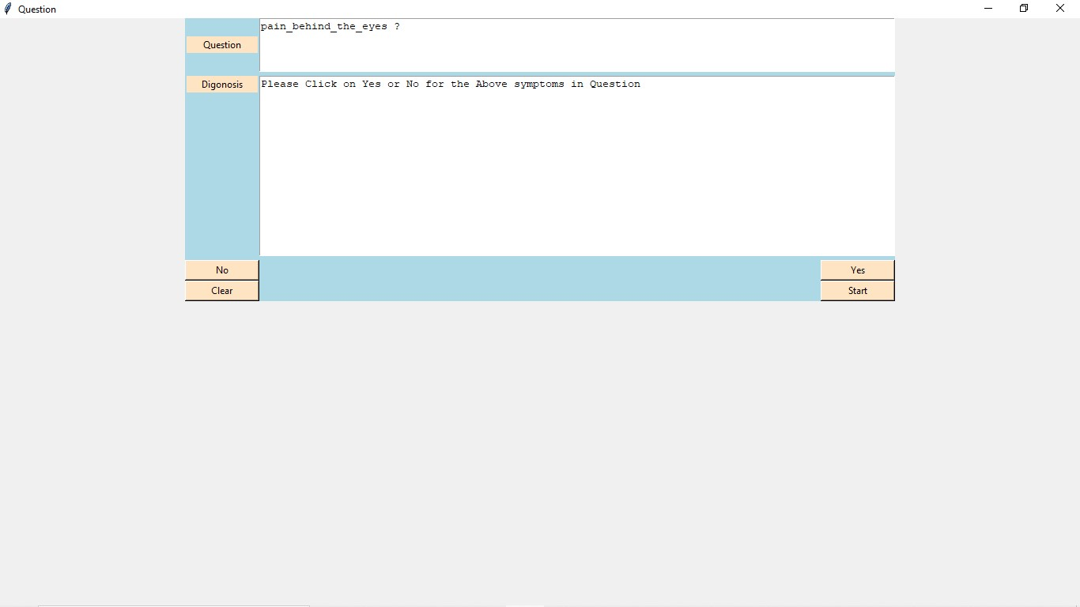

**-06**

**Result Page:**

